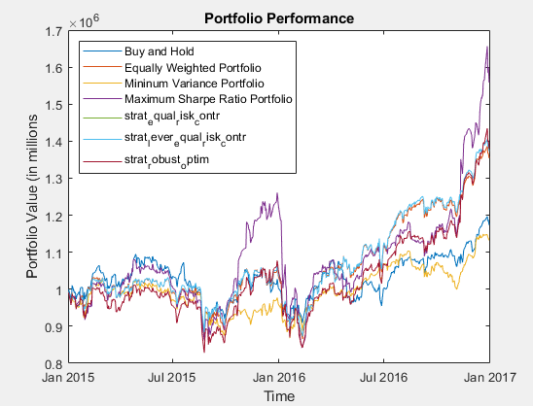

Figure 1

The performance of four strategies is as displayed above in graph.

In the given case,

* equally weighted can be benchmarking strategy
* Min variance represents very risk averse investor
* Max Sharpe ratio represents relatively riskier investor who wishes to maximize returns
* Buy and Hold – random portfolio or based on intuition
* Equal risk contribution
* Leveraged equal risk contribution (not included in graph, I could not understand how to subtract the balance)
* Robust portfolio optimization (Sharpe Ratio (Figure 1) , Min Variance(figure 2)

The graph shows the overall return of all strategies. For the three new strategies:

The graph shows the overall return of strategy 1, 2 and 3 is more or less the same through the trading period, whereas strategy 4 had significant positive deviations in Q4 both years. Overall, for the given period Sharpe ratio delivered the highest compounded return while Min Variance portfolio had the lowest return. I would choose strategy 7 based on my risk tolerance.

**Robust Portfolio Optimization:** I tried to different combinations to analyze how the performance changes based on estimation inputs. First, target return was set to min_variance portfolio return, the portfolio converges to the similar overall return as min variance portfolio.

Figure 2 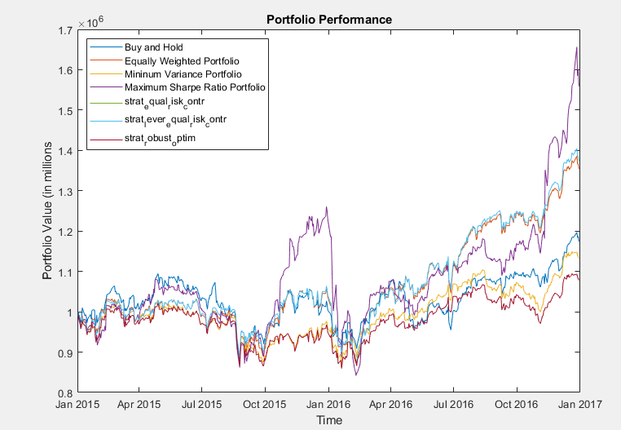

In the second attempt (figure 1) I tried setting the return of Max. Sharpe ratio as target return. This makes SR_ratio strategy robust, making it less volatile and requiring fewer rebalancing while generating a high return.

**Equal risk contribution:** Gradient computations in Matlab file. Equal risk contribution strategy generates a high return as compared to other strategies while ensuring well-diversified portfolio.

Leveraged Equal Contribution: I increased the constraint for portfolio weights from 1 to 2 for 100% leverage but couldn’t understand how to subtract cash borrowed each year.

**Rebalancing Cost:**

Strategies 3 onwards have relatively much higher trading cost As seen from the graphs below and very high volume is traded at each rebalancing.

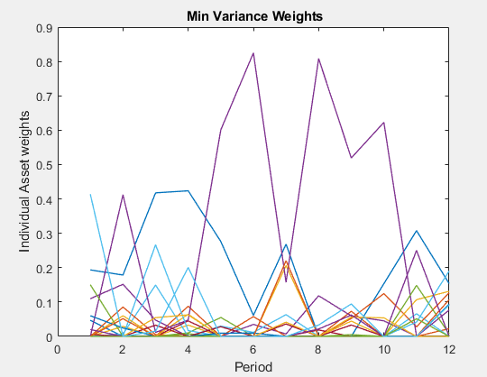

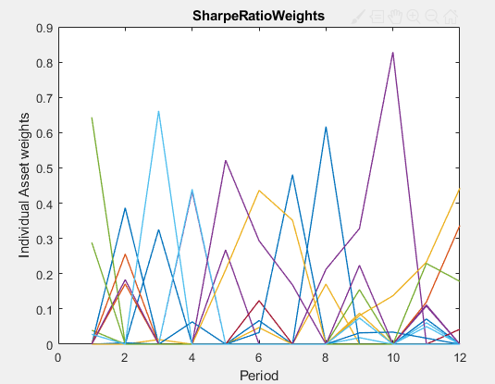

**Return and Rebalancing of Robust mean variance portfolio optimization:**

A relatively more diversification over time series relative to min variance.

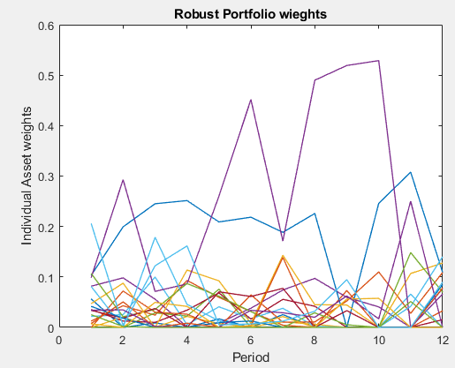

**Return time series, Robust Min Variance portfolio:** Converges to min variance return with less cost.

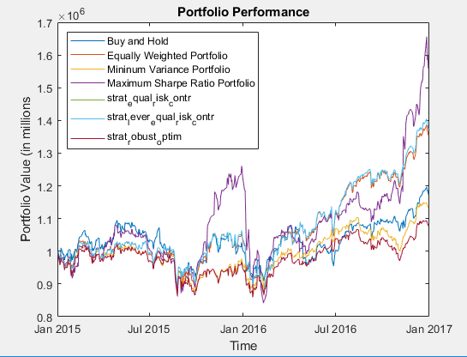

***Testing for year 2008 and 2009:***

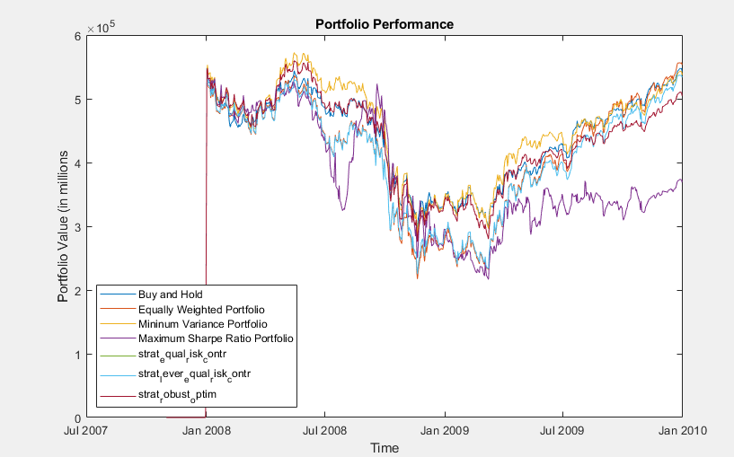

In a bear market, the min variance portfolio outperforms Sharpe ratio portfolio, the robust portfolio optimization converges to min variance cumulative return as well. Another important point note is that most of the portfolio strategies recovers starting quarter 2 of 2009 except Sharpe ratio, inferring that Sharpe ratio strategy is not an optimal strategy in bear market.

My recommendation is robust min variance portfolio for two reason:

1. Minimalizing variance leads to lower downside in bear markets
2. Robustness decreases cost and reduces errors in calculations.

**Portfolio Allocation as a time series**

Strategy 3:

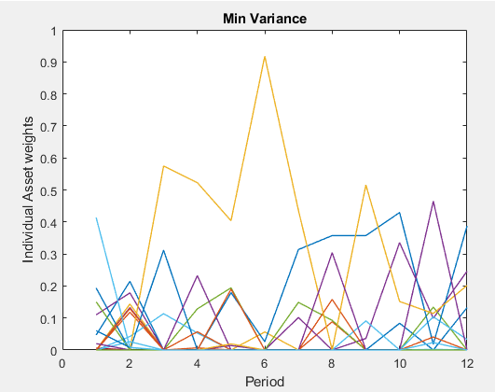

Strategy 4: Very high deviations in allocations, not well diversified and very costly.

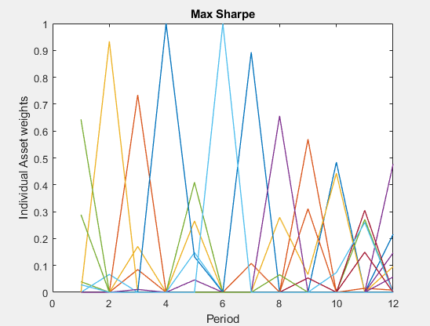

Strategy 7:

Portfolio is well diversified relative to min variance portfolio.

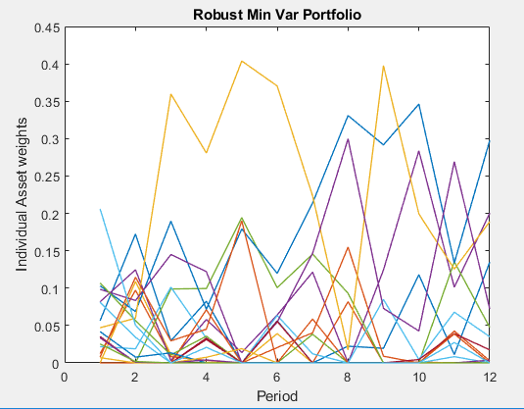

**MATLAB Output for 2008-2009 below:**

Reading daily prices datafile - Daily_closing_prices.csv

Reading daily prices datafile - Daily_closing_prices20082009.csv

Initial portfolio value = $ 574670.56

Period 1: start date 1/2/2008, end date 2/29/2008

Strategy "Buy and Hold", value begin = $ 548247.97, value end = $ 465217.72

Strategy "Equally Weighted Portfolio", value begin = $ 544314.97, value end = $ 469520.52

Strategy "Mininum Variance Portfolio", value begin = $ 543828.97, value end = $ 476011.72

Strategy "Maximum Sharpe Ratio Portfolio", value begin = $ 542765.97, value end = $ 484852.00

Strategy "strat_equal_risk_contr", value begin = $ 544344.97, value end = $ 470879.00

Strategy "strat_lever_equal_risk_contr", value begin = $ 544344.97, value end = $ 470879.00

Strategy "strat_robust_optim", value begin = $ 543998.97, value end = $ 478869.31

Period 2: start date 3/3/2008, end date 4/30/2008

Strategy "Buy and Hold", value begin = $ 462553.95, value end = $ 511257.48

Strategy "Equally Weighted Portfolio", value begin = $ 463140.46, value end = $ 510036.36

Strategy "Mininum Variance Portfolio", value begin = $ 469589.37, value end = $ 543714.69

Strategy "Maximum Sharpe Ratio Portfolio", value begin = $ 478442.40, value end = $ 503863.88

Strategy "strat_equal_risk_contr", value begin = $ 465014.66, value end = $ 506349.98

Strategy "strat_lever_equal_risk_contr", value begin = $ 465014.66, value end = $ 506349.98

Strategy "strat_robust_optim", value begin = $ 473475.15, value end = $ 533888.39

Period 3: start date 5/1/2008, end date 6/30/2008

Strategy "Buy and Hold", value begin = $ 526490.95, value end = $ 486095.76

Strategy "Equally Weighted Portfolio", value begin = $ 527138.65, value end = $ 445795.56

Strategy "Mininum Variance Portfolio", value begin = $ 559173.08, value end = $ 512885.20

Strategy "Maximum Sharpe Ratio Portfolio", value begin = $ 509532.36, value end = $ 434064.01

Strategy "strat_equal_risk_contr", value begin = $ 522575.93, value end = $ 444246.74

Strategy "strat_lever_equal_risk_contr", value begin = $ 522575.93, value end = $ 444246.74

Strategy "strat_robust_optim", value begin = $ 549913.70, value end = $ 493383.84

Period 4: start date 7/1/2008, end date 8/29/2008

Strategy "Buy and Hold", value begin = $ 487307.50, value end = $ 485687.69

Strategy "Equally Weighted Portfolio", value begin = $ 445625.77, value end = $ 451756.52

Strategy "Mininum Variance Portfolio", value begin = $ 512089.62, value end = $ 515252.92

Strategy "Maximum Sharpe Ratio Portfolio", value begin = $ 444478.46, value end = $ 497122.42

Strategy "strat_equal_risk_contr", value begin = $ 444054.99, value end = $ 448844.04

Strategy "strat_lever_equal_risk_contr", value begin = $ 444054.99, value end = $ 448844.04

Strategy "strat_robust_optim", value begin = $ 490533.82, value end = $ 487173.65

Period 5: start date 9/2/2008, end date 10/31/2008

Strategy "Buy and Hold", value begin = $ 478985.24, value end = $ 369998.60

Strategy "Equally Weighted Portfolio", value begin = $ 450719.52, value end = $ 314466.87

Strategy "Mininum Variance Portfolio", value begin = $ 503290.02, value end = $ 382400.15

Strategy "Maximum Sharpe Ratio Portfolio", value begin = $ 496708.23, value end = $ 344948.26

Strategy "strat_equal_risk_contr", value begin = $ 449182.42, value end = $ 320982.07

Strategy "strat_lever_equal_risk_contr", value begin = $ 449182.42, value end = $ 320982.07

Strategy "strat_robust_optim", value begin = $ 479390.76, value end = $ 365042.30

Period 6: start date 11/3/2008, end date 12/31/2008

Strategy "Buy and Hold", value begin = $ 372792.12, value end = $ 338021.03

Strategy "Equally Weighted Portfolio", value begin = $ 313110.94, value end = $ 274379.22

Strategy "Mininum Variance Portfolio", value begin = $ 382690.22, value end = $ 341127.36

Strategy "Maximum Sharpe Ratio Portfolio", value begin = $ 347272.89, value end = $ 295659.63

Strategy "strat_equal_risk_contr", value begin = $ 319671.42, value end = $ 282816.92

Strategy "strat_lever_equal_risk_contr", value begin = $ 319671.42, value end = $ 282816.92

Strategy "strat_robust_optim", value begin = $ 365963.23, value end = $ 335003.05

Period 7: start date 1/2/2009, end date 2/27/2009

Strategy "Buy and Hold", value begin = $ 351630.52, value end = $ 325694.94

Strategy "Equally Weighted Portfolio", value begin = $ 285966.69, value end = $ 251587.69

Strategy "Mininum Variance Portfolio", value begin = $ 351669.93, value end = $ 329815.87

Strategy "Maximum Sharpe Ratio Portfolio", value begin = $ 294570.03, value end = $ 236628.80

Strategy "strat_equal_risk_contr", value begin = $ 294711.71, value end = $ 254404.71

Strategy "strat_lever_equal_risk_contr", value begin = $ 294711.71, value end = $ 254404.71

Strategy "strat_robust_optim", value begin = $ 345969.75, value end = $ 310229.30

Period 8: start date 3/2/2009, end date 4/30/2009

Strategy "Buy and Hold", value begin = $ 316048.57, value end = $ 392525.73

Strategy "Equally Weighted Portfolio", value begin = $ 240454.61, value end = $ 373960.08

Strategy "Mininum Variance Portfolio", value begin = $ 315921.53, value end = $ 437758.26

Strategy "Maximum Sharpe Ratio Portfolio", value begin = $ 223843.77, value end = $ 332775.23

Strategy "strat_equal_risk_contr", value begin = $ 243007.10, value end = $ 368948.32

Strategy "strat_lever_equal_risk_contr", value begin = $ 243007.10, value end = $ 368948.32

Strategy "strat_robust_optim", value begin = $ 298616.78, value end = $ 409112.14

Period 9: start date 5/1/2009, end date 6/30/2009

Strategy "Buy and Hold", value begin = $ 394998.62, value end = $ 426991.87

Strategy "Equally Weighted Portfolio", value begin = $ 373209.88, value end = $ 412300.42

Strategy "Mininum Variance Portfolio", value begin = $ 434000.03, value end = $ 440240.62

Strategy "Maximum Sharpe Ratio Portfolio", value begin = $ 320670.28, value end = $ 350634.98

Strategy "strat_equal_risk_contr", value begin = $ 369164.53, value end = $ 399580.43

Strategy "strat_lever_equal_risk_contr", value begin = $ 369164.53, value end = $ 399580.43

Strategy "strat_robust_optim", value begin = $ 406336.23, value end = $ 414945.25

Period 10: start date 7/1/2009, end date 8/31/2009

Strategy "Buy and Hold", value begin = $ 429930.17, value end = $ 467013.68

Strategy "Equally Weighted Portfolio", value begin = $ 413263.36, value end = $ 463252.72

Strategy "Mininum Variance Portfolio", value begin = $ 438694.52, value end = $ 466120.31

Strategy "Maximum Sharpe Ratio Portfolio", value begin = $ 344376.82, value end = $ 339701.64

Strategy "strat_equal_risk_contr", value begin = $ 399622.04, value end = $ 447483.20

Strategy "strat_lever_equal_risk_contr", value begin = $ 399622.04, value end = $ 447483.20

Strategy "strat_robust_optim", value begin = $ 414035.19, value end = $ 441160.52

Period 11: start date 9/1/2009, end date 10/30/2009

Strategy "Buy and Hold", value begin = $ 457407.27, value end = $ 489396.95

Strategy "Equally Weighted Portfolio", value begin = $ 448023.03, value end = $ 480742.17

Strategy "Mininum Variance Portfolio", value begin = $ 453785.02, value end = $ 479799.52

Strategy "Maximum Sharpe Ratio Portfolio", value begin = $ 318784.98, value end = $ 323468.75

Strategy "strat_equal_risk_contr", value begin = $ 432905.92, value end = $ 462275.53

Strategy "strat_lever_equal_risk_contr", value begin = $ 432905.92, value end = $ 462275.53

Strategy "strat_robust_optim", value begin = $ 430298.07, value end = $ 453001.09

Period 12: start date 11/2/2009, end date 12/31/2009

Strategy "Buy and Hold", value begin = $ 490582.55, value end = $ 542246.05

Strategy "Equally Weighted Portfolio", value begin = $ 482455.81, value end = $ 553239.12

Strategy "Mininum Variance Portfolio", value begin = $ 475665.15, value end = $ 537390.39

Strategy "Maximum Sharpe Ratio Portfolio", value begin = $ 321839.42, value end = $ 369016.85

Strategy "strat_equal_risk_contr", value begin = $ 463781.82, value end = $ 533445.32

Strategy "strat_lever_equal_risk_contr", value begin = $ 463781.82, value end = $ 533445.32

Strategy "strat_robust_optim", value begin = $ 450578.27, value end = $ 504603.86